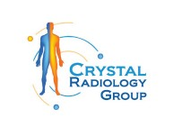The Benefits of Cardiac CT Angiogram: Insights from Harris Park Radiology. (02) 8897 8686

[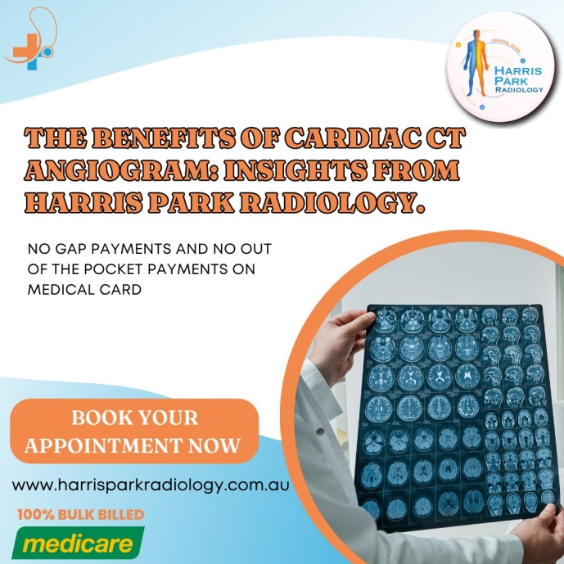](https://crystalradiology.com.au/ct-cardiac/)Cardiovascular disease remains one of the leading causes of mortality worldwide. Early and accurate diagnosis is crucial for preventing serious complications such as heart attacks and strokes. Among the various diagnostic tools available, the Cardiac CT Angiogram has emerged as a powerful, non-invasive method for assessing the heart's [blood vessels](https://crystalradiology.com.au/ct-cardiac/). At Harris Park Radiology, we offer this advanced imaging technique to provide precise and detailed information about your heart's condition, helping you and your healthcare provider make informed decisions about your heart health.

**What Is a Cardiac CT Angiogram?**

A Cardiac CT Angiogram, also known as Coronary CT Angiography (CCTA), is a specialized imaging test that uses computed tomography (CT) technology to capture detailed images of the coronary arteries. These arteries supply blood to the heart muscle, and any blockage or narrowing in these vessels can lead to serious heart conditions, including coronary artery disease.

During a Cardiac CT Angiogram, a contrast dye is injected into a vein in your arm. This dye highlights the coronary arteries on the [CT images](https://crystalradiology.com.au/ct-cardiac/), allowing radiologists to visualize the inside of these vessels with exceptional clarity. The resulting images can reveal plaque build-up, blockages, or other abnormalities that may be affecting your heart's blood supply.

**The Benefits of Cardiac CT Angiogram at Harris Park Radiology**

At Harris Park Radiology, we are committed to providing our patients with the most advanced diagnostic tools available. Here are some of the key benefits of undergoing a Cardiac CT Angiogram at our facility:

**1. Non-Invasive Procedure**

One of the most significant advantages of a [Cardiac](https://crystalradiology.com.au/ct-cardiac/) CT Angiogram is that it is a non-invasive procedure. Unlike traditional coronary angiography, which requires threading a catheter through the blood vessels, a Cardiac CT Angiogram only involves an intravenous injection of contrast dye. This reduces the risk of complications and makes the procedure more comfortable for patients.

**2. High-Resolution Imaging**

Cardiac CT Angiograms produce high-resolution images that allow radiologists to see even the smallest details of your coronary arteries. This level of detail is crucial for identifying early signs of plaque build-up, which can help prevent the progression of coronary artery disease. The clarity of the images also aids in the accurate assessment of the severity and location of any blockages, which is essential for planning effective treatment strategies.

**3. Early Detection of Coronary Artery Disease**

Early detection is key to managing [coronary artery](https://crystalradiology.com.au/ct-cardiac/) disease effectively. A Cardiac CT Angiogram can detect plaque build-up in the coronary arteries before it causes significant symptoms. By identifying CAD at an early stage, your healthcare provider can recommend lifestyle changes, medications, or other interventions to slow the progression of the disease and reduce your risk of heart attack or stroke.

**4. Comprehensive Heart Assessment**

In addition to assessing the coronary arteries, a Cardiac CT Angiogram provides valuable information about other aspects of your heart health. For example, the test can evaluate the size and shape of your heart, detect any abnormalities in the heart valves, and assess the condition of the aorta and other major blood vessels. This comprehensive view of your heart allows for a more thorough assessment of your [cardiovascular](https://crystalradiology.com.au/ct-cardiac/) health.

**5. Quick and Convenient**

A Cardiac CT Angiogram is a relatively quick procedure, usually taking between 30 minutes to an hour to complete. There is no need for an overnight stay in the hospital, and most patients can resume their normal activities shortly after the test. At Harris Park Radiology, we strive to make the process as smooth and efficient as possible, ensuring that you receive your results promptly.

**6. Reduced Radiation Exposure**

Advances in CT technology have significantly reduced the radiation dose associated with Cardiac CT Angiograms. At Harris Park Radiology, we use state-of-the-art equipment that minimizes radiation exposure while maintaining high image quality. This ensures that the benefits of the procedure outweigh the risks, particularly for [patients](https://crystalradiology.com.au/ct-cardiac/) who require repeated imaging tests.

**Conclusion**

A Cardiac CT Angiogram is a powerful tool for diagnosing and managing coronary artery disease. At [Harris Park Radiology](http://crystalradiology.com.au/harris-park-radiology/), we offer this advanced imaging test to help our patients take control of their heart health. By providing detailed images of the coronary arteries and other heart structures, a Cardiac CT Angiogram allows for early detection of heart disease, accurate assessment of blockages, and informed decision-making about treatment options

**Why Choose Crystal Radiology?**

We are local and a privately-owned medical clinics that offers the highest quality medical and Imaging Services in the [Crystal radiology](http://crystalradiology.com.au/harris-park-radiology/) region. We are the leaders in Bulk Billing with the real benefit of no ‘Out of Pocket’ expenses for you.

**Your Next Step**

Please ensure that you have your Medicare card and referral with you and pop into our location for your consultation. If you have any questions at all, please feel free to contact us at [(02) 8315 8292](https://crystalradiology.com.au/appointment/) as we are here to help.